**Assignment 3**



**Spring 2025**

**CSE-408 Digital Image Processing**

Submitted by: **Ali Asghar**

Registration No.: **21PWCSE2059**

Class Section: **C**

Submitted to:

**Engr. Mehran Ahmad**

Date:

**25th June 2025**

**Department of Computer Systems Engineering**

**University of Engineering and Technology, Peshawar**

**Question 1: Frequency Domain Smoothing (Lowpass Filtering)**

Apply and compare frequency domain **smoothing filters** on a grayscale image using Python/ MATLAB. Understand the behavior of each filter in terms of noise reduction and image blurring.

**Instructions:**

1. Implement and apply the following **Lowpass Filters** in the frequency domain:
   * Ideal Lowpass Filter (ILPF)
   * Butterworth Lowpass Filter (BLPF) with order = 2
   * Gaussian Lowpass Filter (GLPF)
2. Cutoff frequency 𝐷0 = 50
3. Perform inverse FFT to get the filtered image.
4. Display and compare:
   * Original image
   * Filtered outputs
   * Their corresponding magnitude spectra

**Analysis:**

* Compare the visual smoothness and edge preservation.
* Discuss which filter best reduces noise and why.

**Code:**

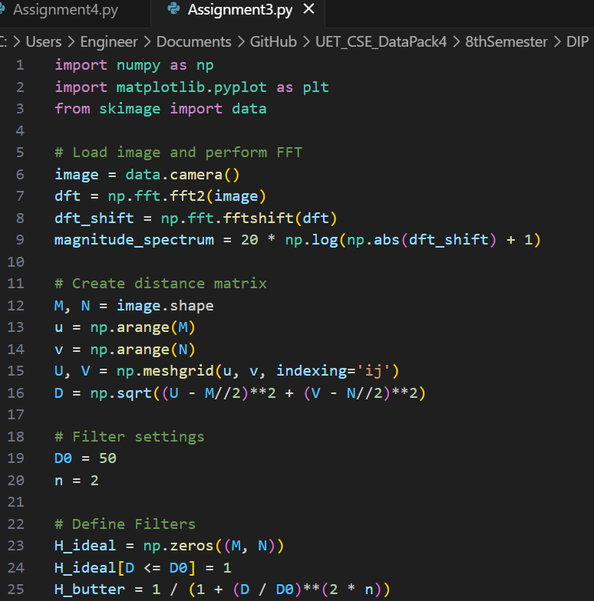

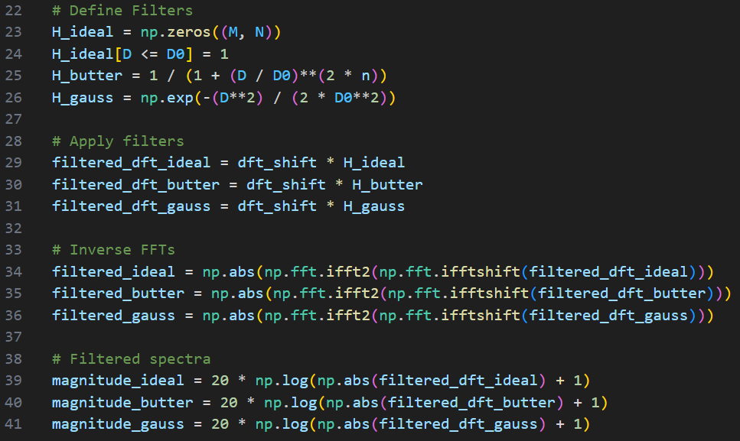

**Output:**

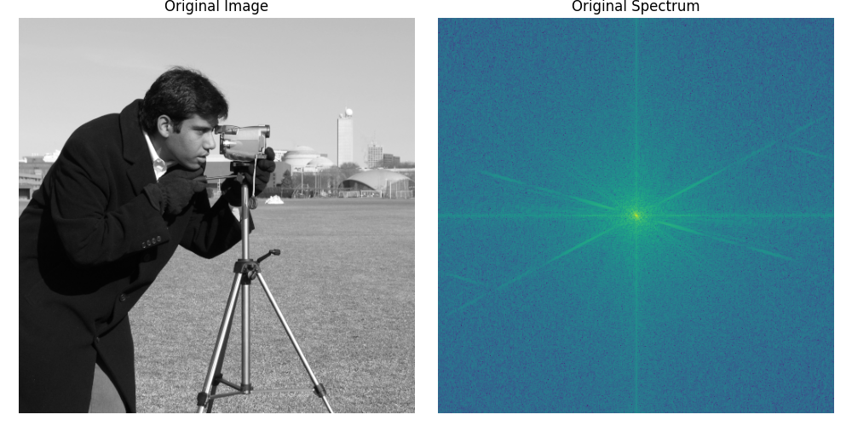***Figure 1: Original Image and Spectrum***

The original grayscale image (Cameraman) and its Fourier magnitude spectrum, showing high-frequency components concentrated around the corners.

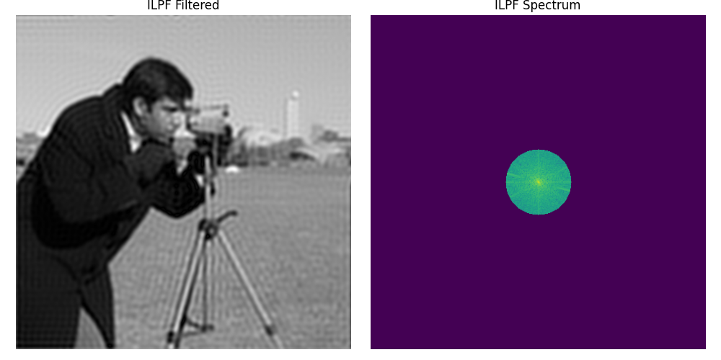

***Figure 2: ILPF Filtered Image and Spectrum***

***Result of applying the Ideal Lowpass Filter (cutoff D₀ = 50). The image shows moderate smoothing with noticeable ringing artifacts around edges due to the abrupt frequency cutoff.***

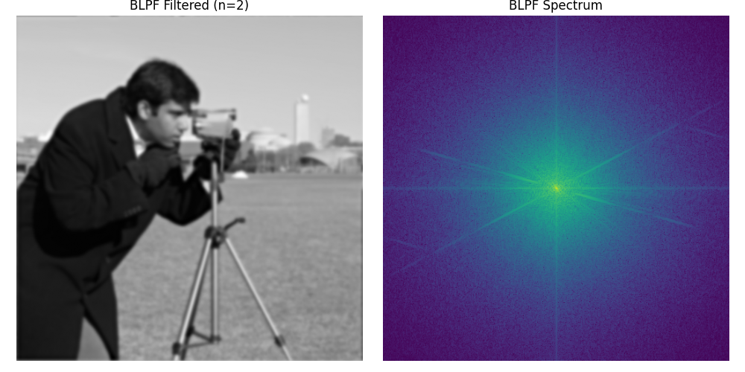

***Figure 3: BLPF Filtered Image and Spectrum***

***Result of applying the Butterworth Lowpass Filter of order 2 (cutoff D₀ = 50). The image is smooth, with better edge preservation than ILPF and reduced ringing artifacts.***

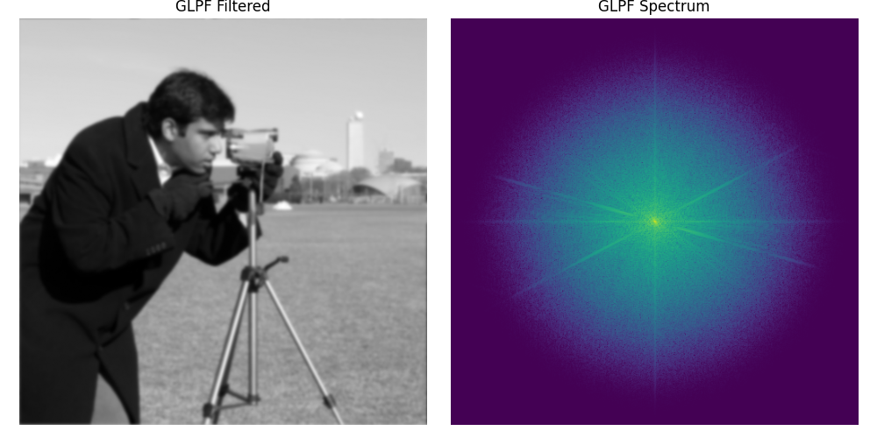

***Figure 4: GLPF Filtered Image and Spectrum***

***Result of applying the Gaussian Lowpass Filter (cutoff D₀ = 50). The image is the smoothest, with minimal artifacts and excellent edge retention, showing a natural attenuation of high frequencies.***

**Analysis:**

This analysis evaluates three frequency-domain lowpass filters—Ideal (ILPF), Butterworth (BLPF), and Gaussian (GLPF)—based on smoothness, edge preservation, and noise reduction.

**1. Ideal Lowpass Filter (ILPF)**

The Ideal Lowpass Filter provides moderate smoothness but performs poorly in preserving edges. It introduces noticeable ringing artifacts around sharp transitions due to its abrupt frequency cutoff (a result of the Gibbs phenomenon). While it reduces high-frequency noise reasonably well, the visible artifacts make it less suitable for applications requiring clean visual quality.

**2. Butterworth Lowpass Filter (BLPF)**

The Butterworth filter delivers higher smoothness than ILPF and offers better edge preservation by avoiding sudden changes in the frequency domain. Its gradual transition helps reduce ringing effects. It effectively suppresses noise, although some image details may be lost due to its strong lowpass behavior.

**3. Gaussian Lowpass Filter (GLPF)**

The Gaussian filter achieves the smoothest output among the three. It preserves edges effectively while reducing high-frequency noise without introducing ringing artifacts. Its exponential decay in the frequency response allows for natural attenuation, resulting in clean and visually pleasing output with minimal distortion.

**Best Filter**

Among the three, the Gaussian Lowpass Filter offers the best overall performance. It achieves excellent noise reduction while maintaining edge fidelity and produces the cleanest result without noticeable artifacts. This makes it the most suitable choice for lowpass filtering in image processing tasks.